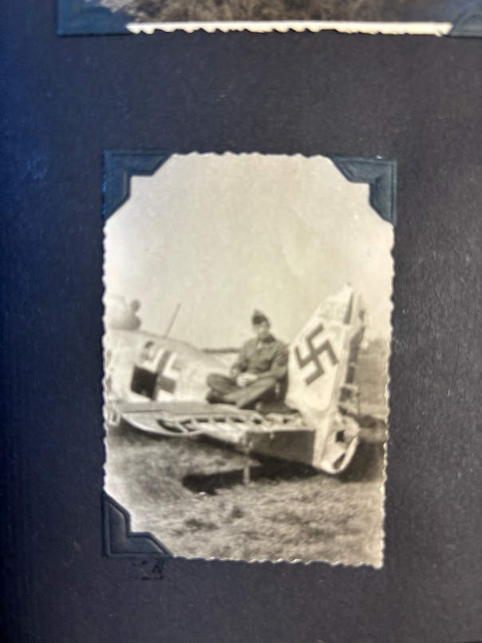 Joe in 1945

Joe in 2024