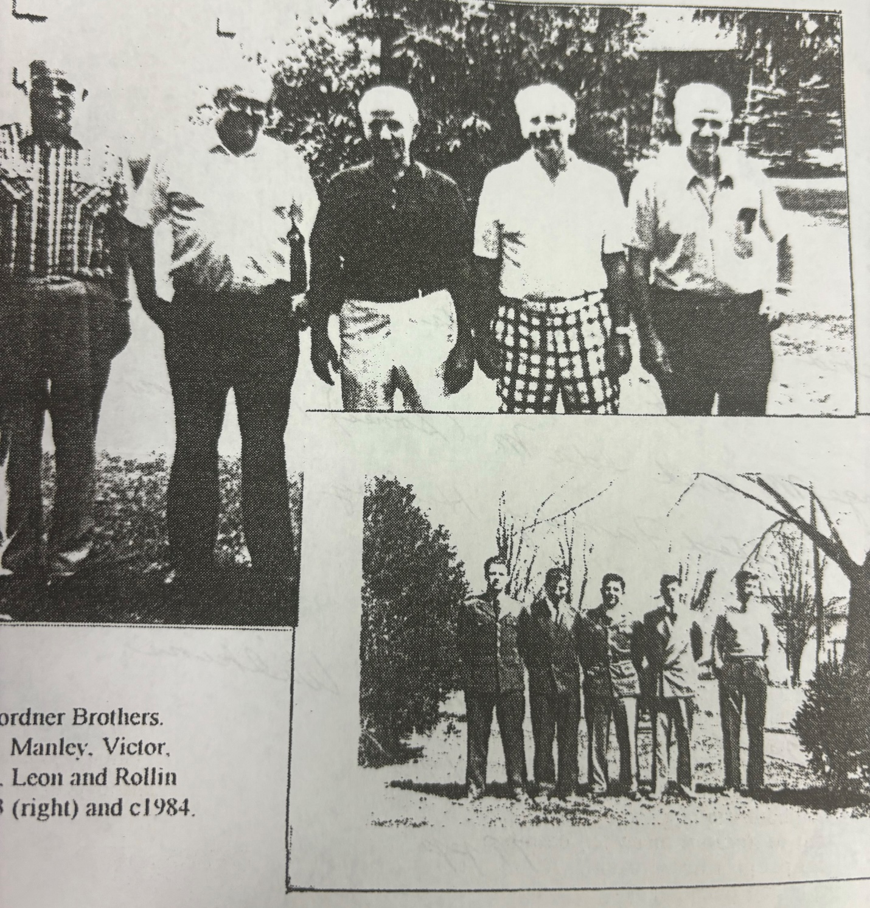
Gordner Brothers: Manley, Victor, Hurley, Leon, Rollin.

